

**DIGITAL STACK: A NFT MARKETPLACE**

**A PROJECT REPORT**

*Submitted by*

**MAZHARUL HASAN**

ROLL No: 11808006

And

**F AHMED ZELANI**

ROLL No: 11808049

***in partial fulfillment for the award of the degree***

***of***

**BACHELOR OF ENGINEERING**

in

**COMPUTER SCIENCE AND ENGINEERING**

**COMILLA UNIVERSITY:: COMILLA-3506**

AUGUST 2022

**COMILLA UNIVERSITY:: CUMILLA-3506**

**BONAFIDE CERTIFICATE**

Certified that this project report “**DIGITAL STACK: A NFT MARKETPLACE**” is the bona-fide work of “**MAZHARUL HASAN AND F AHMED ZELANI**” who carried out the software development LAB-1 under my supervision.MD.

**……………………………….. …………………………**

**PARTHA CHAKRABORTY, ADITI SARKER**  **EXAM COMMITTEE SUPERVISOR**

Assistant Professor Lecturer

Department of Computer Science Department of Computer Science and Engineering and Engineering

Comilla University, Cumilla Comilla University, Cumilla

Abstract

This project is aimed to developing an **IT support system.** The entire project has been developed keeping in view of the distributed client server computing technology, in mind. The project entitled “**IT support system”** is a web application. It is developed by Django, SQLite. The project has tried to incorporate all the advance features of Django to fulfill the aim of the project. The application has designed for taking IT services without any barriers and difficulties.

Acknowledgement

At first, I want to express gratitude to the Almighty Allah for His endless kindness for keeping us mentally and physically t to complete this project.

This project would not get its own shape without the support of the Comilla University which provided us the chance for Bachelor’s Program in computer science and engineering. This project is an aggregate of co-operation of many persons.

Foremost, I would like to express my deepest gratitude to my honorable supervisor, **ADITI SARKR** His vast knowledge, attitude, behavior and wisdom are have given myself the strength to work harder everyday. His directions and guidelines of preparing manuscripts, reports, presentations made us more dynamic and well-organized throughout the whole project. He gave us enough time from the beginning of the project, though he has a tough schedule of his own task.

I also like to thank to all of my honorable teachers in department for giving me the proper guideline throughout entire semester. I want to thank all of my class mates who always inspired, helped and motivated me. I also wish to thank all of my seniors for their utmost supports.

**Chapter Table of contents Page No**

**Abstract ii**

**Acknowledgements iii**

**Comments iv**

**List of Figures v**

**Abbreviations vi**

1. Introduction
   1. Introduction …………………………………………………………… 1
   2. Purpose of IT support system……...…………………………………… 1
   3. Scope Analysis ………………………………………………………… 1
   4. Project Outline …………………………………………………………. 2
   5. Objectives ………………………………………………………………. 2
   6. Contribution ……………………………………………………………. 2
2. Literature Review
   1. Perspective of System ………………………………………………….. 3
   2. Proposed System ……………………………………………………….. 3
   3. Characteristics …………………………………………………………... 3
   4. Constrains ……………………………………………………………….. 3
   5. Used Technology ……………………………………………………….. 3
      1. Software Requirement …………………………………………... 4
      2. Hardware Requirement ……………………………………..….... 4
3. Methodology and Design
   1. System Architecture ……………………………………………………. 5
   2. Data Flow Diagram (DFD) ……………………………………………… 5
   3. Activity Diagram ………………………………………………………… 7
   4. E-R Diagram …………………………………………………………….. 8
   5. User Case Diagram ………………………………………………………. 9
4. Implementation and Result
   1. Login …………………………………………………………………… 10
   2. Home …………………………………………………………………… 11
   3. IT support view …………………………………………………………. 12
   4. Take appointment ……………………………………………………….. 12
   5. Admin page ……………………………………………………………… 13
5. Conclusion and Future Directions
   1. Conclusion ………………………………………………………………. 14
   2. Future Scopes …………………………………………………………… 14

References 14

List of Figures

3.1.1: 0 Level Data flow Diagram ……………………………………………………... 5

3.1.2: 1 level Data Flow Diagram ……………………………………………………... 6

3.3: Activity Diagram …………………………………………………………………. 7

3.4: Entity Relation Diagram …………………………………………………………. 8

4.1: Home page ……………………………………………………………………….. 9

4.2: Appointment section ……………………………………………………………... 10

4.3: Admin panel ……………………………………………………………………….. 11

4.4: It Services ………………………………………………………………………….. 12

4.5: Contact Us page ……………………………………………………………………. 12

4.6: Contact Form page …………………………………………………………………. 13

4.7: Blog page …………………………………………………………………………… 14

Abbreviations

**IDE:** Integrated Development Environment

**DFD**: Data Flow Diagram

**XML:** Extensible Markup Language

**ER-Diagram**: Entity Relationship Diagram

**AI**: Artificial Intelligence

**Chapter 1**

Introduction

* 1. Introduction

A non-fungible token is a processed data (token) unit maintained on a blockchain that is not interchangeable with other digital assets for the purposes of this definition (nonfungible). The term "fungible" is derived from economic and accounting literature and refers to anything that may be replaced with a comparable or identical commodity. Traditional kinds of currency, whether comparable amounts of paper money or same quantities of precious metals, are fungible, making them valuable as mediums of exchange since they are perceived to be of similar worth. A five-dollar note may be substituted with five one-dollar bills since the two currencies are fungible. Regulated commodities, common shares, financial options, and bills of money are all examples of fungible assets. A non-fungible asset, on the other hand, could be a person's car, because someone borrowing a friend's car would not be able to repay their loan to their buddy by giving them another person's car. Baseball cards, for example, are a classic example of nonfungible assets since each card has unique characteristics that increase or decrease its value in comparison to other baseball cards. Objects in the virtual world were once deemed to be difficult to prove their uniqueness and distinguishability in order to be considered "non-fungible." Code is code: 1s and 0s that may be regenerated and are hence, to a significant extent, fungible. [1]

* 1. Purpose of IT support system

The objective of IT support system project is to provide online information and technological support for their needs.

1. Ensure efficient and reliable communication with client for IT support
2. To Enable online primary IT solution
3. To Enable Automated Data Entry method
4. Enable easy authorized modification of data.
5. Enforce security measures to avoid unauthorized access to guest records.
6. Enable fast and easy retrieval of guest records and data for fast reference activities.  
     
   1. Scope Analysis

Not every company needs a comprehensive, proactive IT support plan. Instead of pushing unnecessary services, we add value by offering dedicated support options that provide the proper resources and expertise for your business objectives and projects. Bring Data Evolution experts onto your team in a custom capacity to keep your operations efficient while you focus on what you do best.

* 1. Project Outline

This project report will be structured as follows:

Chapter 2 introduces the Literature Review containing background knowledge and related

works in this field.

In Chapter 3, we present an overall interpretation of the methodology and design of the

project work.

In Chapter 4, we discussed about the results and how we implemented the Hotel Management System.

Finally in Chapter 5, we conclude this project report with the future objectives for our system and an overall epilogue.

* 1. Objectives  
     IT support system provide deep technical expertise and guidance to implement clients IT project smoothly. Our goal is to-
* Build the most secure aspirational, concrete IT support services
* Continuously improve web sites and conversions, meetings standard manner
* Provide a top-performing services
* Achieve top sales among competitors in the region
* Increase market reach

* 1. How it works

The process used in NFT creation includes uploading the file on the NFT market place [2], where it is saved as an NFT on the digital ledger and so that it can be bought or sold using digital currency. While an artist creation of an NFT which reflect a work of art may be exclusive to them, and they can maintain the copyright to the work and so manufacture more NFTs based on the same work. As a result, a person who purchases an NFT does not automatically acquire copyright of the original digital file, nor does he or she have exclusive access to it. One of the things that drew the attention of casual NFT market observers is that buyers do not instantly become owners of original objects, and they have no method of confirming that the file has not been duplicated or used by any other artist or the buyer [3]. The origination problem, which is ubiquitous in other forms of blockchain technology, is also available in the NFT space: anybody may potentially contribute their own or someone else's artwork to an NFT without establishing that they are the original artist. This increases the real-world risk of imposters uploading NFTs to auction platforms under the guise of being the genuine owners or manufacturers of valuable products.

* 1. Technical Components of NFTs

1. Blockchain

As explained by Nakamoto, Bitcoin employs the “proof of work” [4] technique to achieve consensus on transaction data in a distributed system. Blockchain is a distributed, attached-only database that maintains track of a list of data entries that are linked and secured using cryptographic methods [5]. Blockchain technology provides a solution to the long-standing Byzantine dilemma, which was solved by a large network of dishonest individuals. Because any changes to the recorded data render all subsequent data incorrect, the shared data on the blockchain becomes immutable after it has been validated by the majority of nodes. Because it provides a secure environment for smart contract execution, Ethereum is the most often used blockchain platform in NFT schemes [6].

1. Smart Contract

Smart contracts [7] were initially proposed by Szabo as a means of speeding up, verifying, and executing digital agreements. Ethereum advanced smart contracts in blockchain technology. Blockchain-based smart contracts leverage Turing-complete scripting languages to perform complex operations and strict state transition replication through consensus procedures to ensure ultimate consistency. Smart contracts enable unknown parties and scattered participants to conduct fair transactions without the need for a trusted third party, and they also provide an uniform foundation for designing applications across a wide range of sectors. Apps that operate on top of smart contracts benefit from state-transition mechanisms. All users have access to the states containing the directions and parameters, assuring that the directions are carried out in a transparent manner. Furthermore, the placements of states between distant nodes must stay constant, which is crucial for consistency. Most NFT systems leverage smart contract based blockchain platforms to enable order-sensitive executions.

1. Address and Transection

Blockchain addresses and transactions are fundamental concepts in cryptocurrencies. A blockchain address is a unique identifier allowing a user to move and receive assets, just like a bank account when using money in a bank. It is composed of a series of alphanumeric characters generated by a pair of public and private keys. To transfer NFTs, the owner must show that s/he possesses the appropriate private key and send the assets to another address(es) using a valid digital signature. This straightforward activity is typically performed using a bitcoin wallet and is referred to as submitting a transaction to use the ERC-777 [8] smart contract standard

1. Data Encoding

Encoding is the process of changing data from one type to another. Many files are often encoded in either efficient, compressed formats to conserve memory or uncompressed formats to achieve high quality/resolution. In popular blockchain systems such as Bitcoin [9] and Ethereum, hex values are utilized to encode transaction components such as function names, arguments, and return values. This means that the actual NFT data must follow these rules. When someone claims ownership of NFT-based Ip rights, they are basically claiming ownership of the creator's original hex value chunk. Others may freely copy the raw data, but they cannot claim ownership of the property. As a result, we might witness an increase NFT related actions.

* 1. Tokenization of NFT

In this part we will talk about the token standards that are related to NFTs, and these tokens contains ECR-20 [11] , ECR-721 [11] , and ERC-1155 [12]. For NFTs, there are a variety of token standards. Because it consist of an shareable Solidity smart contract mechanism that allows developers to create new contracts just by importing it from a library (OppenZeppelin source library), the Ethereum ERC-721 standard of CryptoKitties was the first to be used for the NFT category. Another important Ethereum version is the ERC-1155 standard, which provides "semi-fungible" alternatives and the ability to create ERC-721 assets. Bitcoin Cash and Flow (from the founders of Cryptokitties) are two more NFTcompatible protocols, in addition to Ethereum.

Some Code of ERC-721

The most widely used token standard is ERC-20. It presents the notion of fungible tokens, which are fungible tokens that may be issued on Ethereum if certain requirements are satisfied. Tokens are compared to one another according to the standard . All other tokens have the same value: a random token. This has fuelled the "Initial Coin Offering (ICO)" mania from 2015 to the present. Many public chains and blockchain-based DApps receive their initial financing in this manner. ERC-721, on the other hand, offers a NFT standard that is distinct from fungible tokens. This is a unique token that can be distinguished from others. Every NFT has a token_Id uint256 variable, and the combination of contract address and uint256 token Id is globally unique. Additionally, the token Id can be used as an input to generate unique identifications such as zombie or cartoon character images.

* 1. Net Properties

Because NFT systems are fundamentally decentralised applications [13], they benefit from the features of their underlying public ledgers. The following is a list of the most important properties.

1. Authenticity
2. Transparency
3. Accessibility
4. Tamper-resistance
5. Usability
6. Atomicity
7. Tradability

**Chapter 2**

Literature Review

2.1 Perspective of System

In contrast to platforms such as Spotify and Netflix, which provide unlimited digital content for a subscription fee, NFT platforms are built around the idea that just like physical content, digital content too can be scarce — that is, limited in quantity — and can therefore be meaningfully owned and traded. These platforms leverage blockchain technology to verify the provenance of digital content, similar to how a traditional auction house might verify that a given work of art is in fact the original and not a replica, and some platforms even offer the ability to “burn” items, further reinforcing the concept of scarcity for these digital products. Blockchain-based transaction logs can also facilitate royalty attribution, automatically sharing a percentage of revenue from second-hand sales with the original creator every time the NFT is traded.

Of course, as with any investment into a new capability, while partnering with the right marketplace can unlock entirely new markets and revenue streams, partnering with the wrong platform can seriously backfire — and when it comes to leveraging a rapidly-evolving new technology like NFTs, it’s not always obvious what the right choice is. To avoid making costly mistakes, it’s critical to understand the landscape of platforms that are currently available and determine which will be the best fit for your NFT offerings.

[2]

2.2 Proposed System

While there are a number of factors to consider, we’ve found that it can be particularly helpful to characterize NFT marketplaces on a spectrum from *streamlined* to *augmented*. Streamlined marketplaces support a broader range of NFTs and offer more limited, generic services to sellers, while augmented marketplaces are highly specialized and provide a more full-service experience.

Streamlined platforms include services such as **OpenSea** and **Rarible**, which host both auctions and fixed-price sales for a wide variety of NFTs, and more closely resemble traditional platforms such as eBay, Esty, or Mercari. These marketplaces focus predominantly on enabling efficient transactions, often providing payment infrastructure to accept both credit cards and crypto payments in Bitcoin, Ethereum, and occasionally other specialty tokens. They offer minimal additional services, and because of their breadth, these platforms generally have fairly large and varied user bases.

Augmented marketplaces, on the other hand, tend to focus on narrower niches, and offer numerous value-added services such as minting (creating the NFT itself), marketing, curation, pricing recommendations, portfolio trackers, and even full-blown games built on top of the NFTs. For example, the NBA’s Top Shop focuses exclusively on basketball collectibles that the platform packages and markets, SuperRare focuses on visual art and provides extensive curation and recommendation services, and Sorare, which focuses on digital sports cards, hosts fantasy soccer competitions that incorporate the cards users buy on the platform.

These specialty services can add a lot of value, but of course, they come at a cost. To account for the resources required to build out, integrate, and support an array of customized tools and experiences, augmented platforms generally have a higher “take rate,” or transaction fee, as well as higher upfront setup costs. Streamlined marketplaces typically have lower initial and ongoing costs, but may require sellers to invest their own resources or hire external experts to design, mint, and market their NFTs.

2.3 **Engage with the market**

So, how can you determine which type of platform is the best fit for your business? Companies with a large pool of intellectual property and a target audience within a specific domain may find it beneficial to partner with an augmented platform. A larger quantity of monetizable content generally means a larger upfront investment is more likely to pay off, and these specialized platforms can draw on their niche experience to ensure a successful launch and drive additional value through secondary tools and services.

If you’re not sure what kinds of specialized services might be a good fit for your business, it’s worth looking to other creators’ NFT experiments for inspiration. For example, artists may leverage these platforms to offer exclusive video content, or sports teams might include a free meet-and-greet or VIP upgrade with NFT purchases. McLaren Racing recently launched a program where fans can collect various components of a Formula 1 race car in digital form, and the first fan to collect all 22 of the NFTs required to assemble a complete digital version of the car will win an all-expenses-paid trip to a Formula 1 race.

In addition, some augmented platforms offer detailed data analytics around when other NFTs on the market were minted, how many NFTs competitors are minting, average prices, sales numbers, and more. Firms can then use this data to make informed choices about how they mint and price their own digital offerings. For example, NBA Top Shot offers a detailed analytics page for each NFT that includes a breakdown of related market activity, ownership history, and other information about the video highlight. Similarly, electronic music marketplace RCRDSHP presents users with extensive analytics on both individual NFTs and on the overall state of the market. Although these industry-specific platforms may have narrower reach, they can be extremely effective within a given market — Sorare, for example, generated nearly $20 million in transaction volume last month and over $100 million in the past year.

For products with broader appeal, however, companies and creators may be better off partnering with a streamlined marketplace. For example, Coca-Cola partnered with OpenSea to auction off a “Loot Box” NFT that included digital versions of a vintage Coca-Cola cooler, jacket, and logo, as well as a real, fully-stock Coca-Cola refrigerator delivered to the winner’s home. It was a simple enough offering that didn’t require much in the way of custom, industry-specific specialization, and so OpenSea’s streamlined platform was a good fit. (The NFT collection ultimately sold for over $575,000, which Coca-Cola donated to Special Olympics International.)

* 1. Constrains

Although non-fungible tokens (NFTs) have been around since 2018, NFT market momentum began its surge in the second half of 2020. The ecosystem’s nascent climb continued in 2021, reaching a total sales volume of 2.5 billion USD during the first half of 2021 compared to over 9 million USD in the second half of 2020.

However, amid the backdrop of rapid demand growth for NFTs, creators are consistently facing congestion in public chains and an uptick in gas costs, which has resulted in hundreds of users holding back their NFT-based transactions. As a result, the digital art revolution that has immense potential to transform the relationship between creators and collectors hasn’t materialized as expected.

For instance, the yearly NFT report by Non Fungible clarifies that when Ethereum’s gas prices dropped, NFT transaction volumes peaked. However, with high gas costs, the NFT market became almost exclusively open for ‘whales.’ Given that most transactions were only from high-value NFTs, these obstructions prevented new artists and traders from attempting to enter the burgeoning market.

* 1. Used Technology

A technology stack contains all the technologies, tools, and frameworks you will use during NFT marketplace development. This will include smart-contract development, codings, blockchain & other development platforms, data storage, security management, and UI design tool, among other web services.

* + 1. Software Requirements

1. Operating System: Microsoft Windows 11/10/8.1/Linux/macOS

2. Framework: Moralis, Graph Blockchian

3. Decentralized database Server: IPFS, Pinata, Infura

4. Front-End: Html, CSS, JavaScript, Bootstrap, NextJS, Twilandcss,

5. Back-End: Solidity (smart contract), web3js, etherjs,

6. IDE: VS Code, Gitpot

7. Ethereum

8. Hardhat

9. Metamask

* + 1. Hardware Requirements

1. Core – i7 processor
2. RAM 8 GB
3. SSD Hard Disk 222 GB

**Chapter 3**

Methodology and Design

In this chapter we will present an overall interpretation of the methodology and design or our implemented system.

* 1. **Architecture of NFTs**

Architecture is about art and science and NFT gives a platform to all the architects big or small to showcase their talents and create masterpieces. These pieces will stay forever in the virtual world with the help of blockchain. Nothing gets lost on it and if someone wants to find out about the creator, they can use the metadata element to get all the information. There are so many platforms on which you can create the NFT’s.

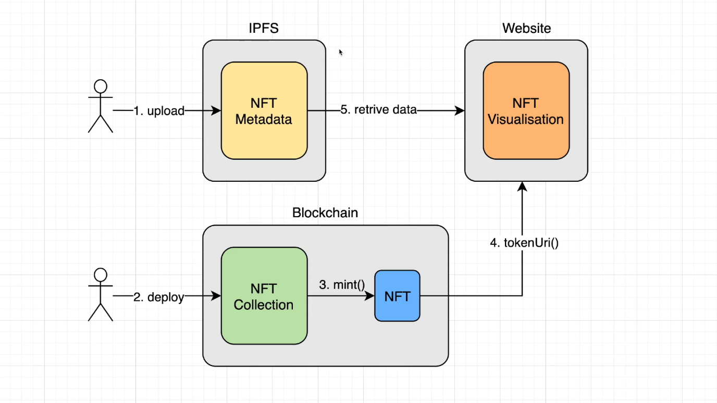We know that NFT works on [blockchain technology](https://www.analyticssteps.com/blogs/blockchain-technology-explained-components-and-applications) especially on the [Ethereum](https://www.analyticssteps.com/blogs/what-ethereum-all-you-need-know) blockchain. A simple NFT is minted from tangible and intangible items like- art, GIFS, videos and highlights, designer sneakers, music, images etc. Now architectural designs are also included in NFT.

* 1. Architecture of NFT Marketplace

The**NFT marketplace** means a platform that gathers numerous vendors and brands to sell digital assets to a curated customer base.

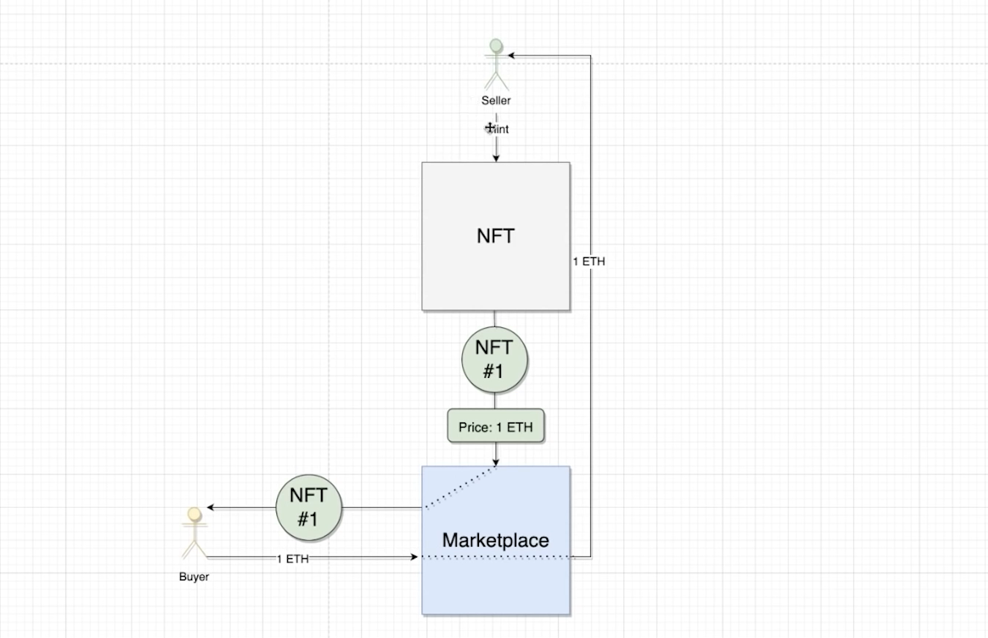

* 1. **Components of NFT Marketplace**

If we’ve managed to inspire you, and you are ready to design & develop an NFT marketplace like OpenSea, the most essential architecture components are:

* **Blockchain technology integration.** There are multiple types of blockchain networks (public, private, consortium, and hybrid). Along with such public technologies as*IBM Blockchain, Ethereum, Ripple, or Cords,* some brands go for new options. *For example, NBA Top Shot*uses its own new blockchain, called [*Flow*](https://www.onflow.org/).
* **Minting.** A computer process validates data, creates a new block, and recordes it into a blockchain. Minting deserves special attention. It’s vital to think in advance if you want to allow NFTs with upfront gas costs or if you wish to introduce lazy minting, 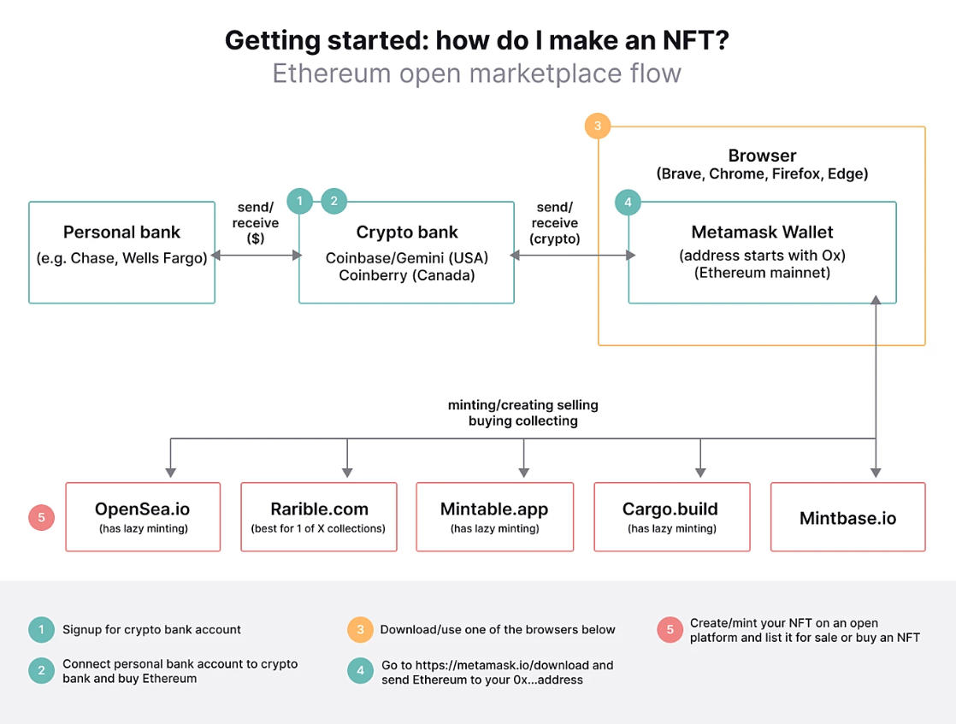which does not require any gas.

**Fig: A complete architectural diagram of NFT marketplace using many marketplace like opensea, raible, cargo, mintable etc.**

* **Token types.**You should define the types of NFT tokens the platform will support. For example, Opensea supports the majority of NFTs, including ERC-721 and ERC-1155.
* **Navigation.**The user experience is the king. To ensure a smooth journey, it’s vital to plan what your NFT marketplace navigation should be like.
* **On-boarding.**Gone are the days when the user had enough patience to fill in forms with multiple fields. Smooth on-boarding is a must. Thus, make sure to provide options such as social logins.
* **Advanced filters.**Ensure the available NFT assets are easily searched for and found in full compliance with the users’ preferences.
* **Effective listings.** A product page can make or break a sale. Listings with digital assets must be highly informative, include item descriptions and details, current pricing (with an equivalent in USD), and a CTA button designed in full compliance with the niche best practices.
* **Secure access to a blockchain wallet.** It is one of the biggest concerns for many. Safe access to a crypto wallet is important or even more of a concern when compared to a traditional eCommerce marketplace
* **Analytics (transparent price history).**The majority of NFT marketplaces offer a bidding system for their digital assets. As a result, the ability to overview the shift of interest is required to keep the fire burning.
* **And of course, a catalog with digital assets.**A collection of any products requires systematic compilation. NFT marketplaces are no exception. [CryptoPunks](https://www.larvalabs.com/cryptopunks), [Cryptofranklinks](https://cryptofranklins.com/), and [CyberKongz](https://opensea.io/accounts/CyberKongz) can serve as beautiful examples of digital assets.
  1. EIP-721: Non-Fungible Token Standard

The following standard allows for the implementation of a standard API for NFTs within smart contracts. This standard provides basic functionality to track and transfer NFTs.

We considered use cases of NFTs being owned and transacted by individuals as well as consignment to third party brokers/wallets/auctioneers (“operators”). NFTs can represent ownership over digital or physical assets. We considered a diverse universe of assets, and we know you will dream up many more:

* Physical property — houses, unique artwork
* Virtual collectables — unique pictures of kittens, collectable cards
* “Negative value” assets — loans, burdens and other responsibilities

In general, all houses are distinct and no two kittens are alike. NFTs are distinguishable and you must track the ownership of each one separately.

**Chapter 4**

Implementation and Result

4.1 Home

This is the starting of the web application. All functionality can be accessed from the home. Users can browse through the different section of the website and they can get the desired services from this home page.

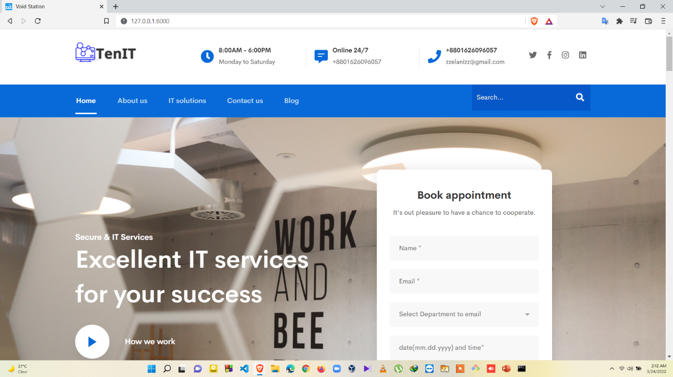

Fig 4.1: Home page

4.2 Appointment System

From this section a user can take appointment online. Then admin will ensure user with replying an email.

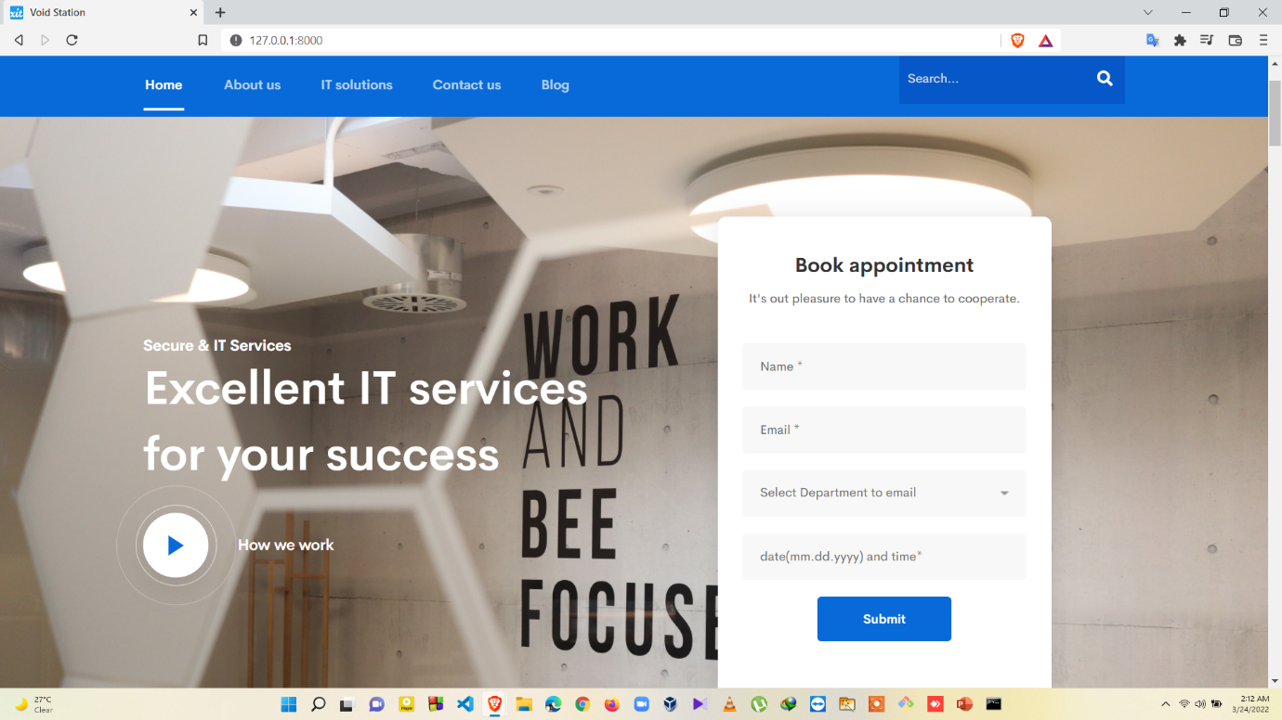

Fig 4.2: Appointment section.

4.3 Admin Page

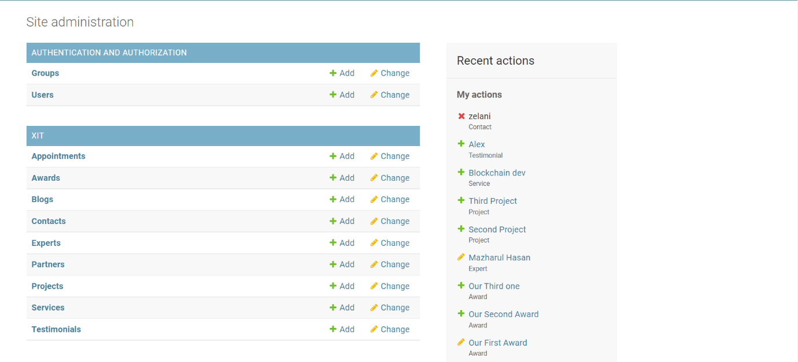

Fig 4.3: Admin panel.

4.4 IT services

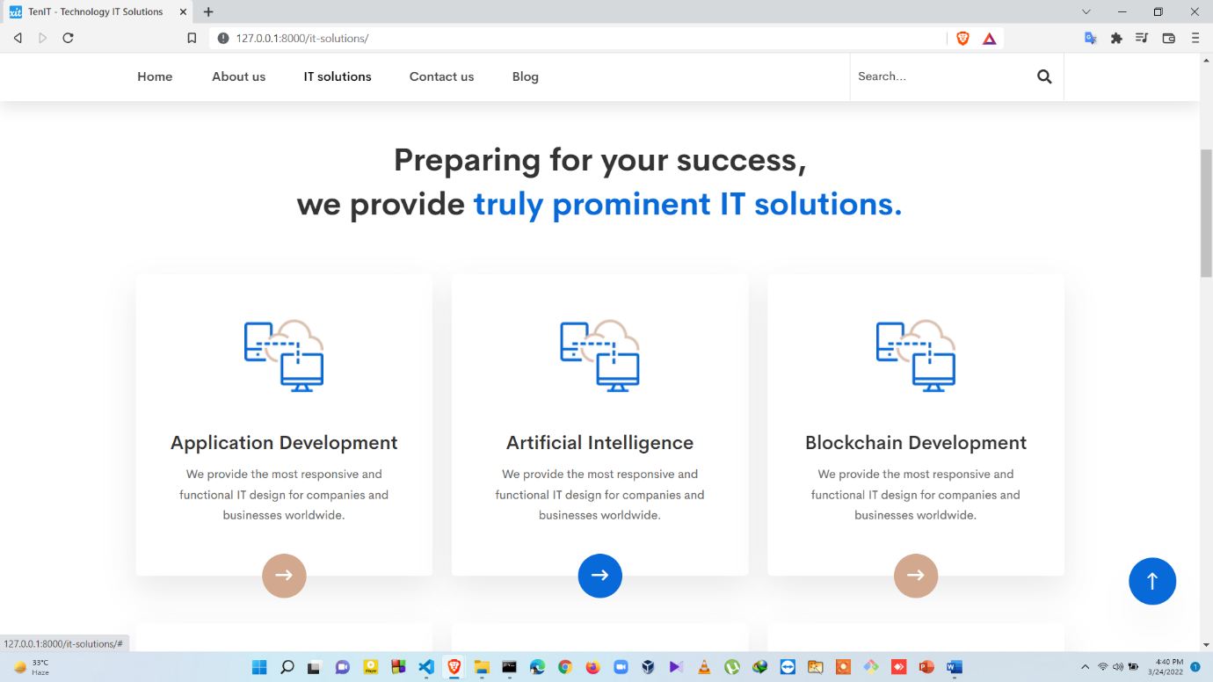

Fig 4.4: It Services

4.5 Contact Us

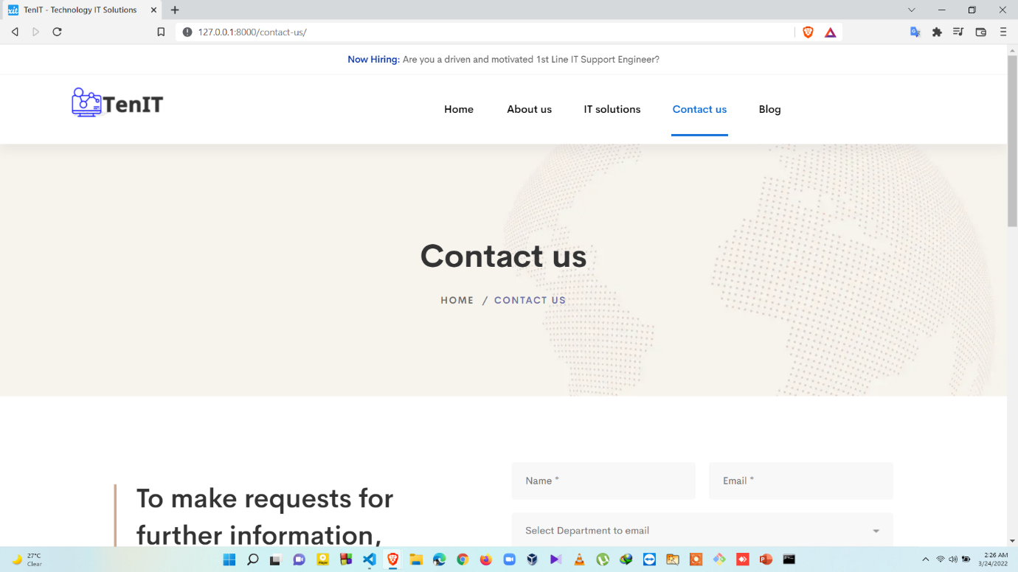

Fig 4.5: Contact Us page

4.6 Contact-Form

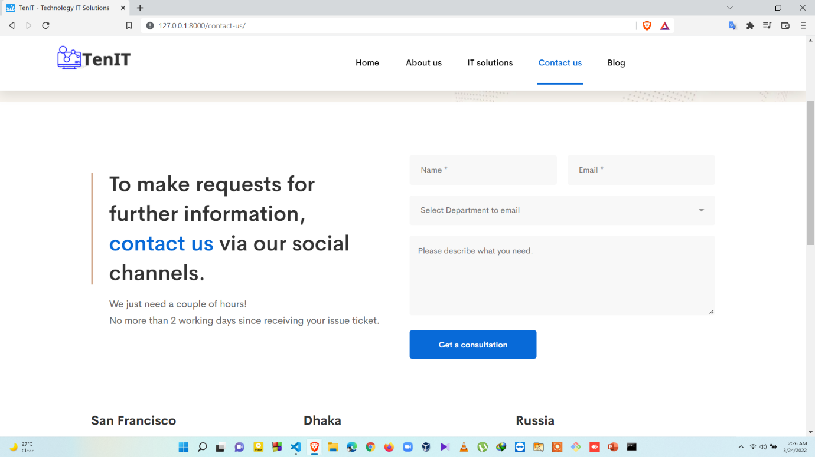

Fig 4.6: Contact Form page

4.7 Blog Page

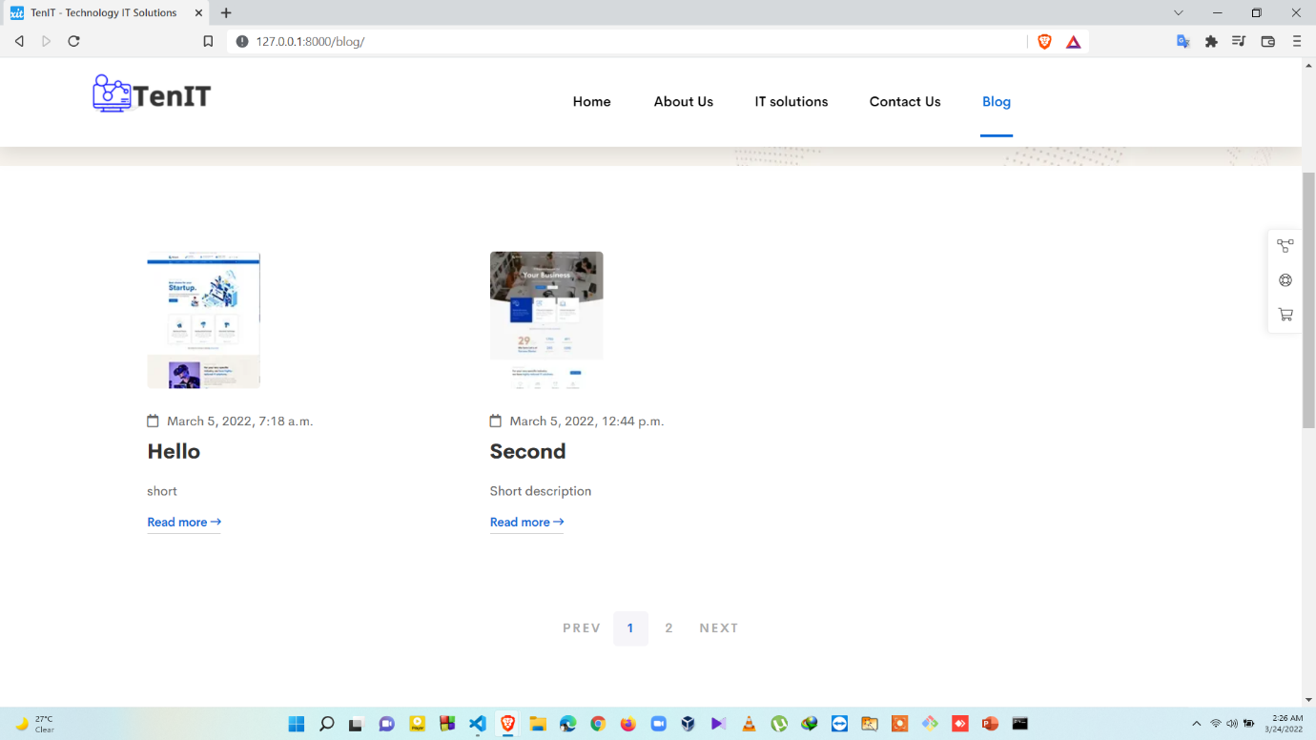

Fig 4.7: Blog page

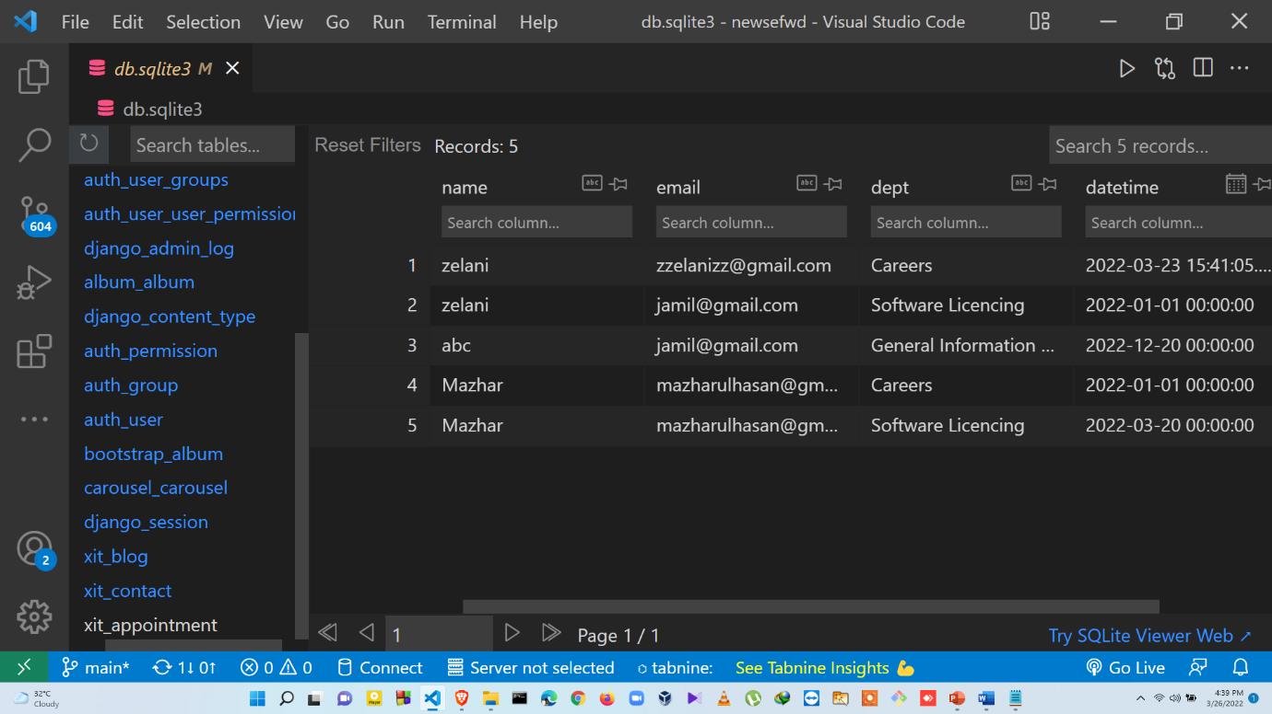4.8 Database table for Appointments

Fig 4.8: Appointments in database

**Chapter 5**

The project provided us the opportunity of interacting with our teachers and to gain from their best experience I think that all kind of people of our country will get a great benefit from this project.

5.1 Conclusion

So, our system is here to provide a convenient way to clients to take proper guidelines, services from IT experts. Clients also can take online or offline appointments from anywhere in the world. They will get update our services, achievements through blog posts. People can get update about Advanced Technologies such as Cloud Storage, Blockchain dev, AI, NFT, Cryptocurrency etc. Also free consultation of uses of advanced technologies from our IT experts.

5.2 Future Works

The IT management System has been developed with a main aim of making work easier and time saving for the human capital. The whole system only has single language at present and can be extended to other languages too with minor changes (not in coded).

The coding pattern is kept as dynamic as possible with minimum number of static values to make it easier for future extensions. As the current system is expected to add more functionality and dependency according to requirement changes and technology, proper coding standards and working platform have been kept in mind to produce a quality product.

One enhancement is that we can make this application in more than 1 language as well. Adding live or interactive room mapping is also one option for enhancement.

**References**

[1] C. Usman W, "Non-Fungible Tokens: Blockchains, Scarcity, and Value," Critical Blockchain Research Initiative (CBRI) Working Papers, p. 14, 2021.

URL: <https://www.dataev.com/it-project-support>

[2] Brain Station IT solution- ‘The Ultimate Guide to IT Outsourcing’.

URL: <https://brainstation-23.com/?ba>

[3] Irene Luque Ruiz -Nieto Miguel(2008) ‘Databases and Similarity Analysis Based on Molecular Graphs Isomorphism’. URL: <https://www.researchgate.net/publication/225109752_A_Java_Tool_for_the_Management_of_Chemical_Databases_and_Similarity_Analysis_Based_on_Molecular_Graphs_Isomorphism/figures?lo=1&utm_source=google&utm_medium=organic>